Unmoderated studies don’t have a live moderator guiding you through the session. Instead, you’re given a set of tasks or questions to complete on your own, on your own time.
What that actually looks like in real life is pretty straightforward. Once you qualify, you’ll get access to a study and a set of instructions. From there, you’re basically walking through it step by step by yourself.
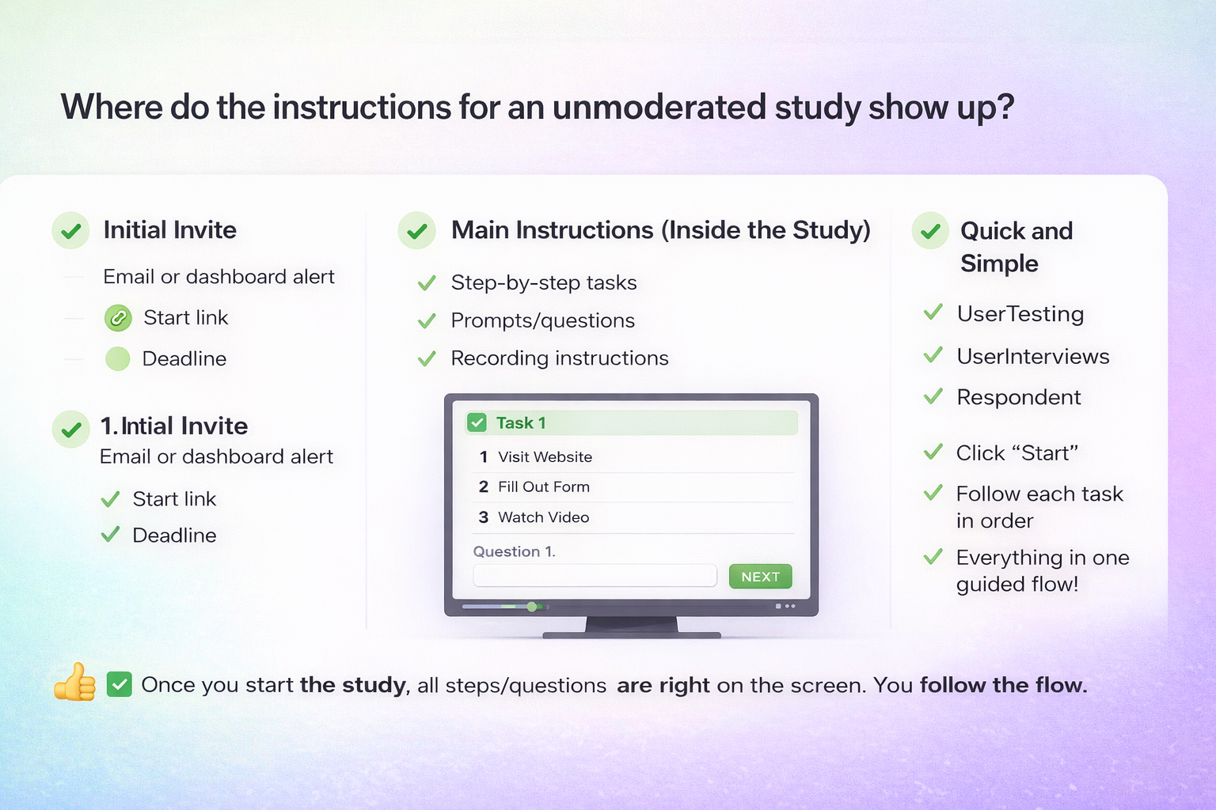
A lot of times, you’ll be asked to record your screen and your voice while you do something. That could be navigating a website, going through an app, or trying to complete a task like signing up for an account, finding a product, or checking out. While you’re doing that, you’ll be talking out loud — saying what you’re thinking, what’s confusing, what feels easy, what you like, what you don’t like.
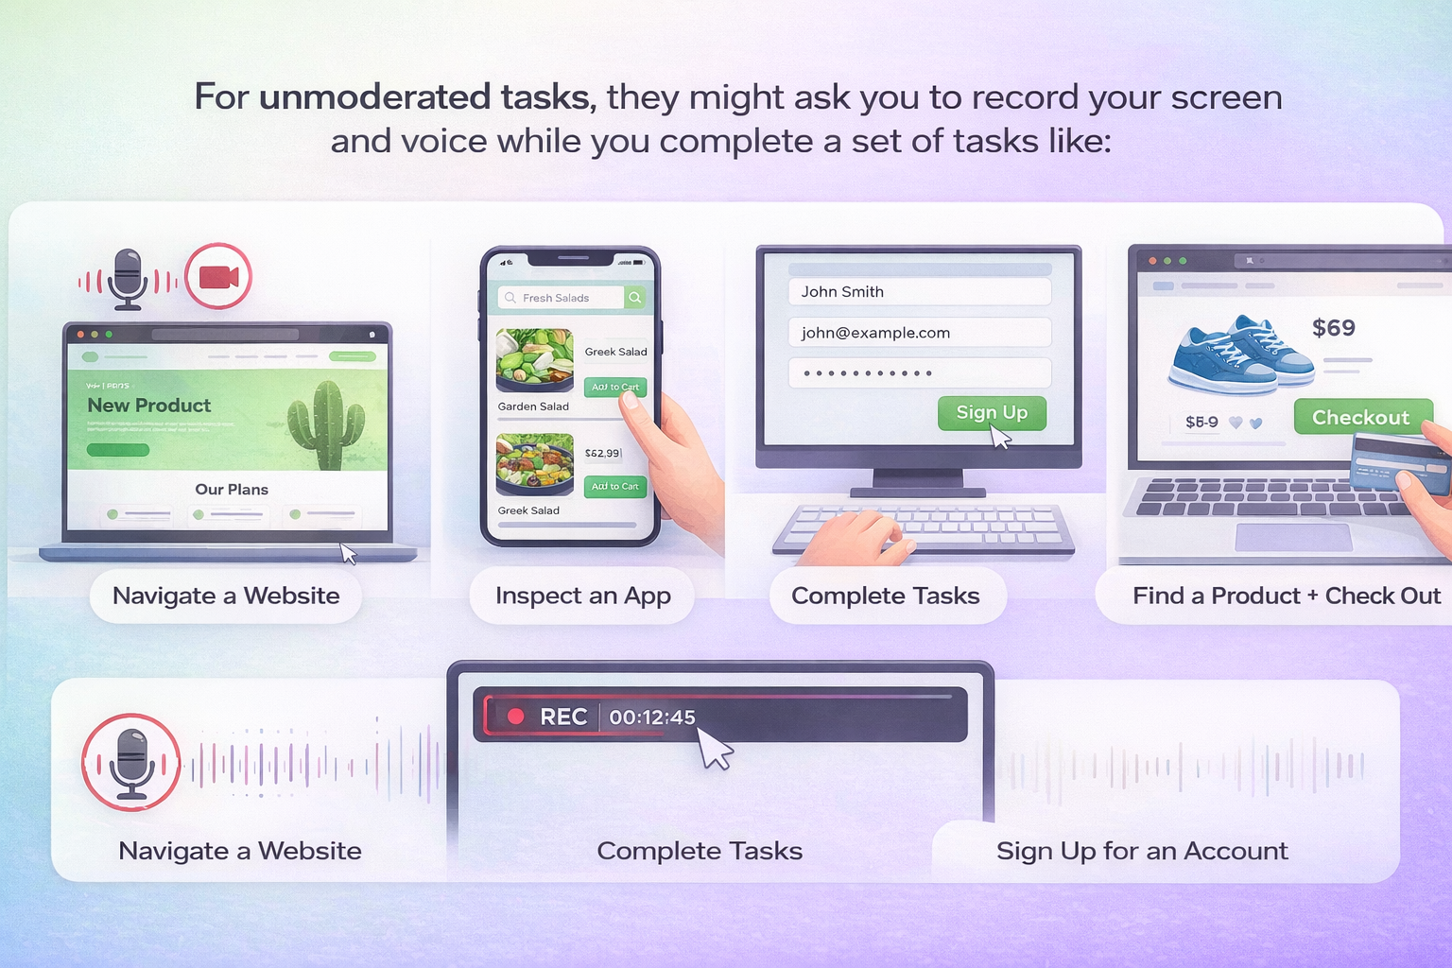
For example, you might be told: “Go to this homepage and tell us what you think this company does.” Or: “Try to find a specific product and talk through how easy or difficult that is.”
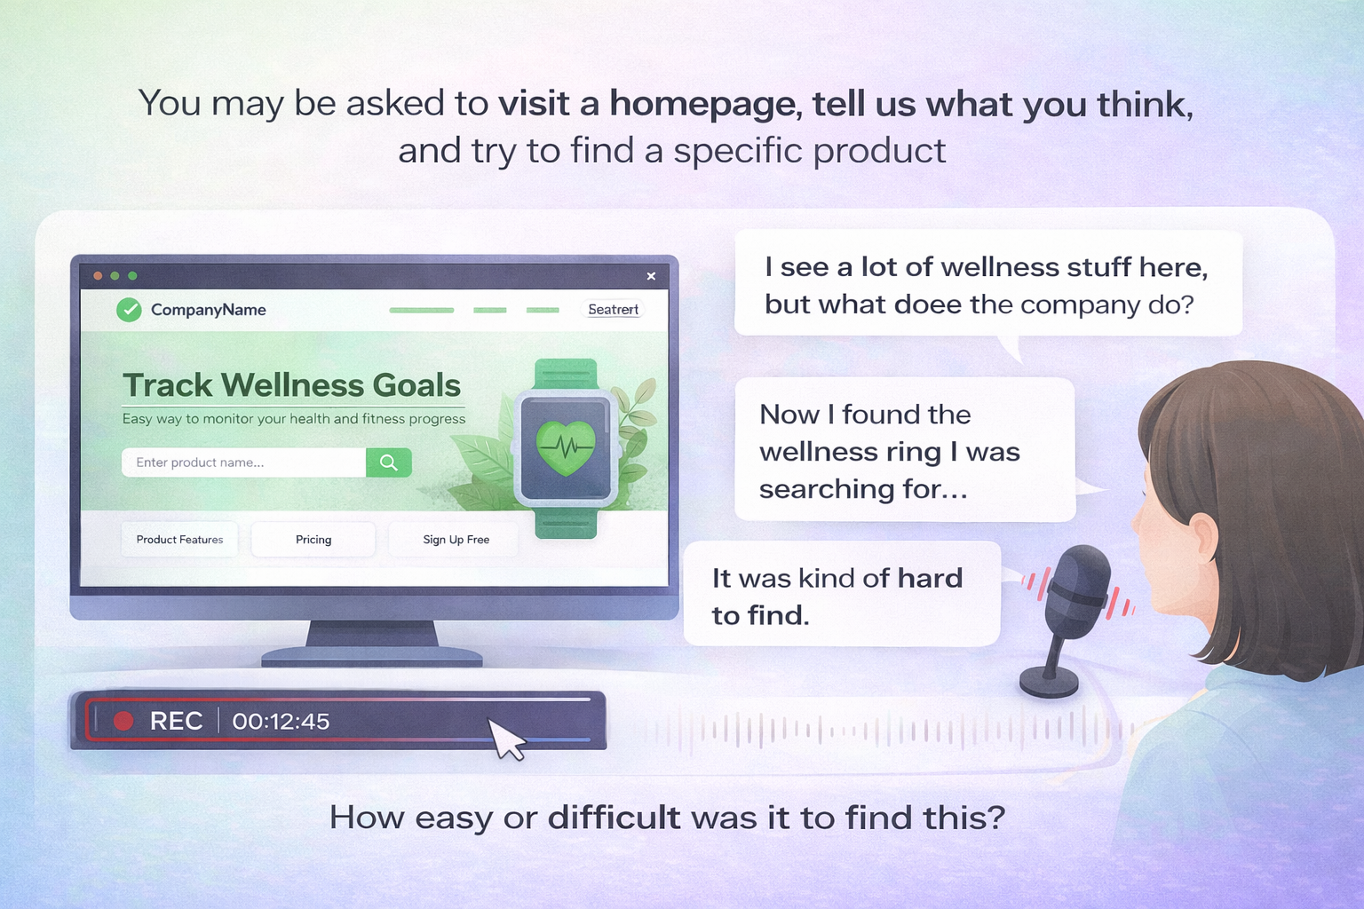
Other times, it’s less about navigation and more about your reactions. You could be shown an ad, a landing page, or even just a concept, and asked to explain your first impression, whether you trust it, and if it would make you take action.
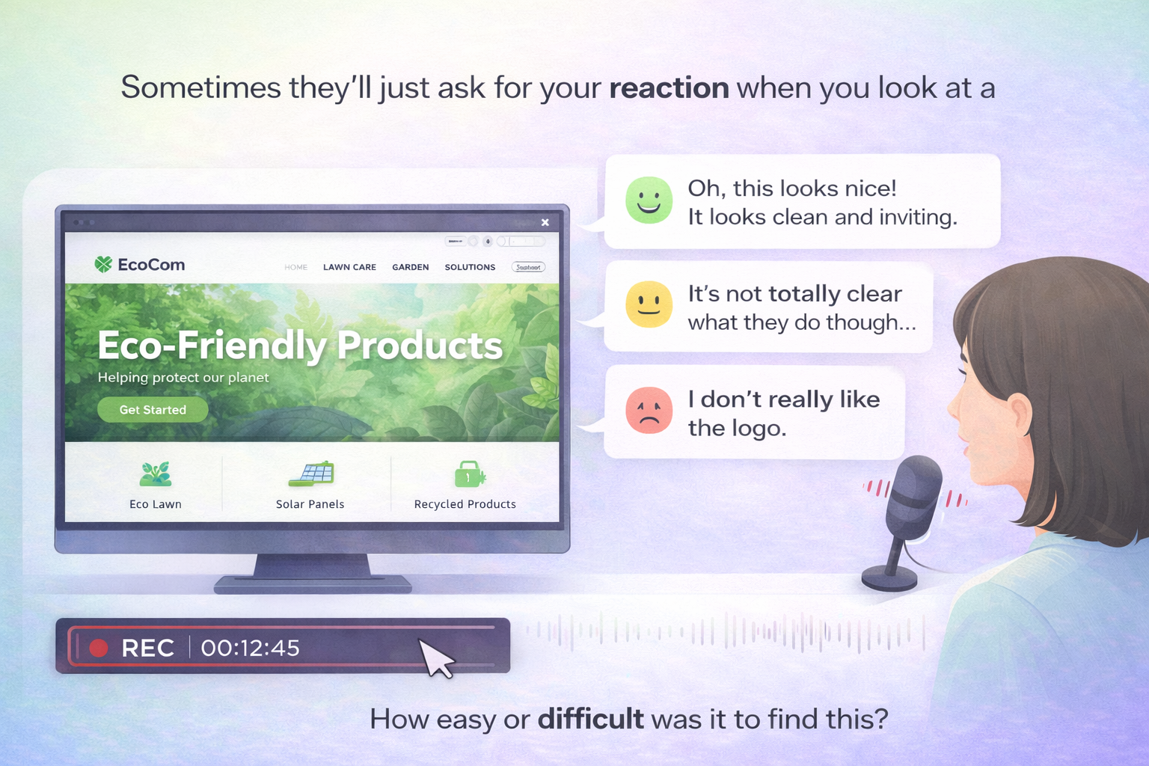
Some studies are even simpler — just written or video responses. You might answer open-ended questions, upload short clips of yourself reacting to something, or give feedback after trying a product for a few days.
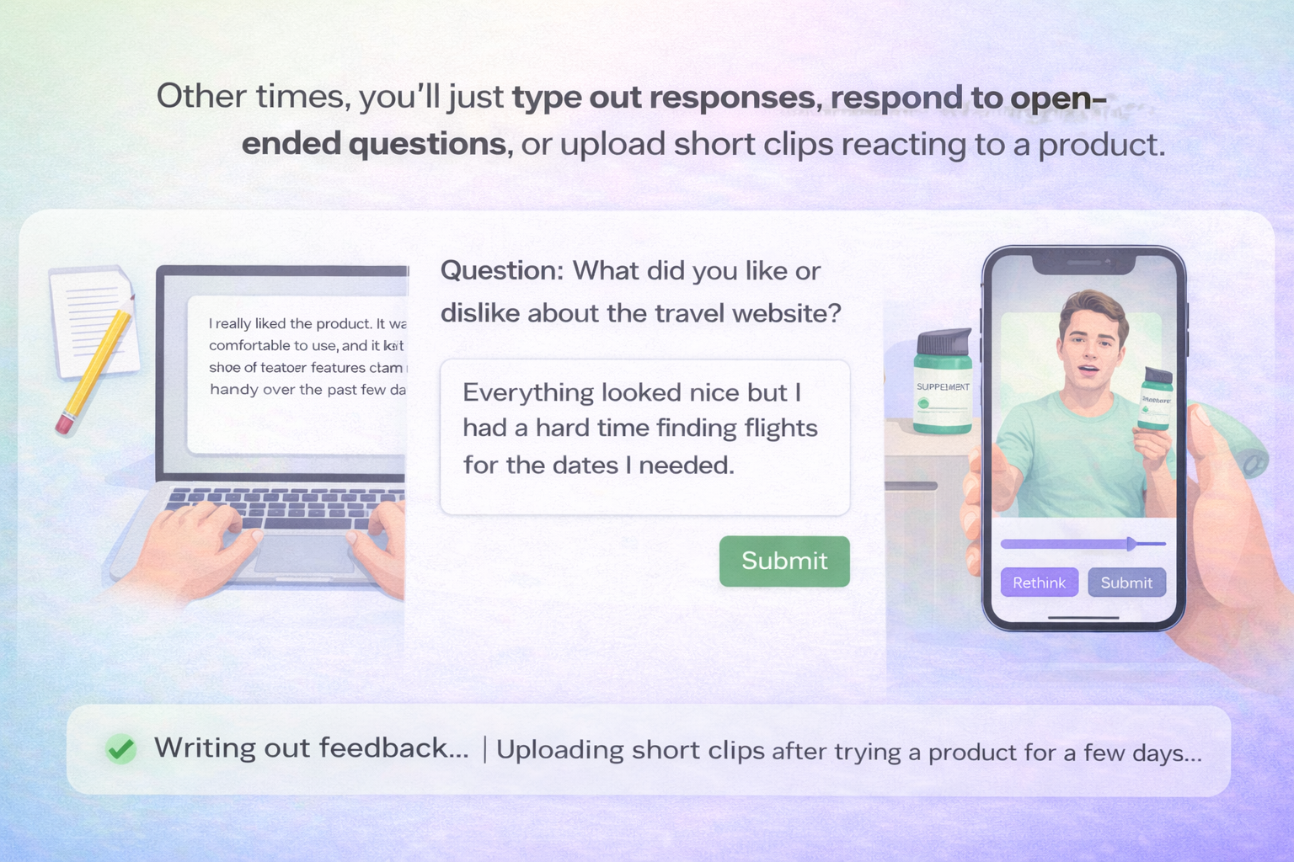
The big difference here is there’s no one interrupting you, no one asking follow-ups in real time. So it’s really about you being clear and honest as you go. If you go quiet, there’s no one there to pull more out of you — so the more you naturally talk through your thoughts, the better.
These tend to be shorter and more flexible than moderated sessions. You can usually do them whenever it fits your schedule, as long as you meet the deadline.
Pay typically falls in the $10–$50 range, depending on how long or involved the study is.
Some of the higher-paying ones are what are called usability tests — and all that really means is you’re testing how easy or confusing something is to use, like a website or an app. In those cases, you’re usually recording your screen and talking through what you’re doing while you try to complete a few simple tasks.
Those can pay closer to $60 for about 20 minutes, especially on platforms like UserTesting, if you’re the right match for the study.
This covers the basics. You’ll learn more as you do these studies and it will become second nature.
Well this is it for this lesson! In the next lesson I’ll be covering Product Tests. You won’t want to miss it – product tests are tons of fun and very often you even get to keep what you’re sent to test.
Thank you for your time, I appreciate you and I’ll see you in the Product Test lesson.
Earn a little extra money right now even while you’re going through the course! Just click the big red button and start.


